Spring Boot - Location Based Web Socket Application

Created by: Rutvik Patel
Date: 04/04/2019

Definition:

- Create Web Socket Endpoint that is receiving location from users.
- Web socket broadcast all user's location to all connected users.
- Display Map on page.
- User can select his location and press Live Button.
- Upon clicking on live button, his location will be shared every 10 seconds to the server via WEB SOCKET.
- Display all other user's location in the Map.

Solution:

Technology used:
Server Side = Spring Boot for web application
Spring Web Socket for managing socket communication from server side

Client Side = Html5 Geolocation from browser for getting user’s live actual location from web page
SockJS for web socket communication from web page
Bootstrap for web page design
Jquery for web page interaction

In this project I haven’t used any database for storing the data. I have stored data in memory.

Bellow I have described screenshot of the application,

- Firstly, when user enter in the application then, He/She have to provide username.

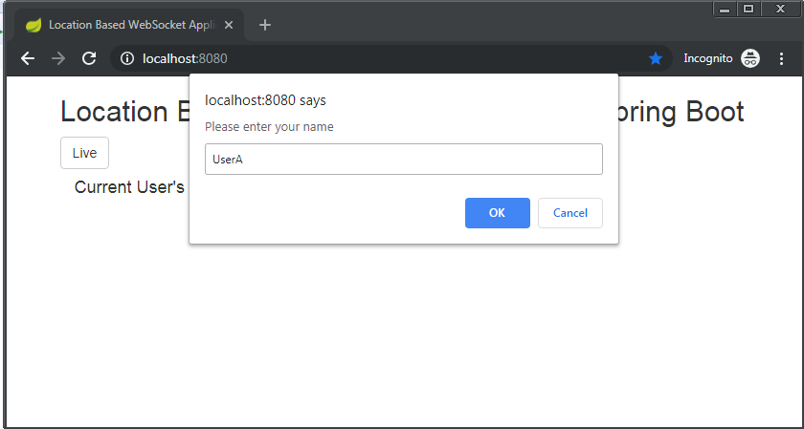

- If user has entered username as [UserA]. Then, web page shows that user’s current location.
In that time no other user is online so, public user’s data is blank.

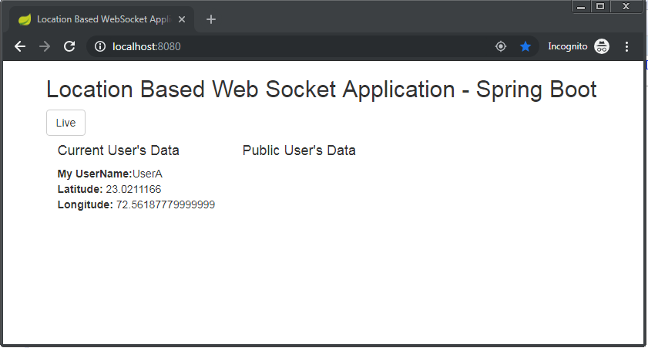

- In that time if other username called [UserB] is enters.

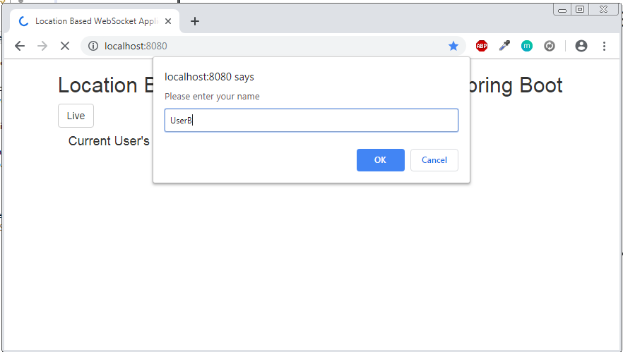

- [UserB] is show his/her current location on page

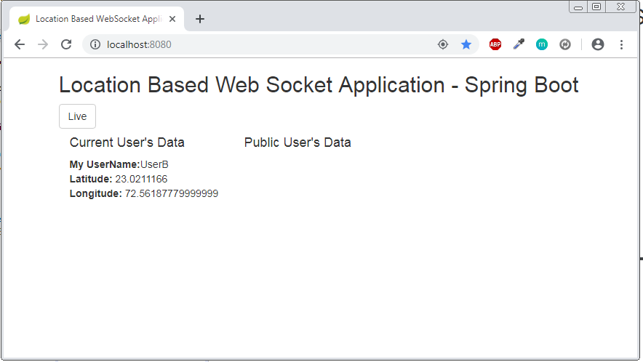

- After clicking on Live button on page in both the user’s screen, All connected user’s latest location is getting feed from server via web socket and current user continuously sending their location to web server form web page.

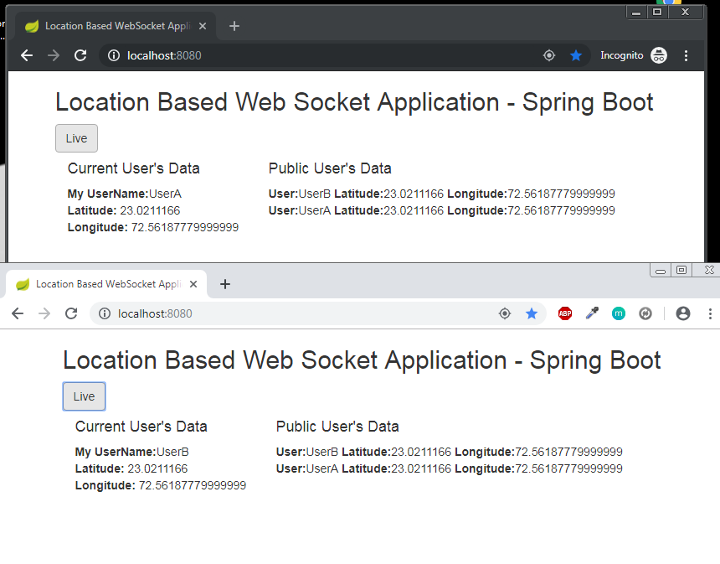

- In this process, User have to allow access of location from browser to get their location

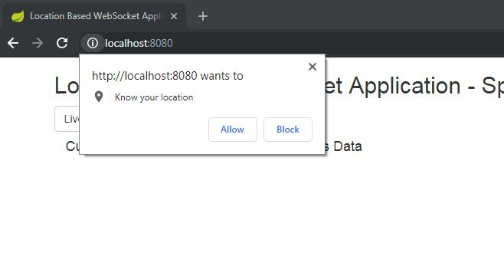

- Project structure of the project

